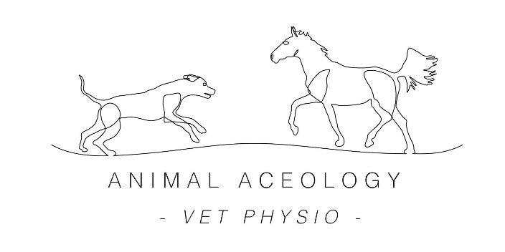

Sponsorship Terms & Conditions
- Applicants must be within 25 miles of LU7 (if not you may still apply but there would be a small travel charge for each session dependant on location. If you would like to know how much before applying message me for more information)
- Applicants must regularly compete (in any discipline) or attend training sessions/clinics at various venues
- Applicants must be active and regularly post on Instagram, Facebook or both
- Applicants must be willing to complete either an owner, vet or both consent form (depending on your horses situation)
- The winner will actively engage with Animal Aceology Veterinary Physiotherapy (Facebook) and animalaceology_vetphysio (Instagram) and tag them in their posts
- The winner will share pictures of their sessions with Animal Aceology Veterinary Physiotherapy and tag the account
- Two free sessions will be given throughout the years sponsorship and be taken between 1st February 2021 and 31st December 2021
- The winner will receive 25% off all other sessions and must agree to have at least one more additional session alongside the two free sessions
- The winner will wear their branded saddle pad regularly for photos and while out competing/training
- This winner must be willing to sign this Terms & Conditions sheet to agree to the above

